Teacher: Stornes | Course: English III
Room: 239 | Email: MOOREL2@scsk12.org
Course Description:
English III offers a comprehensive exploration of American literature exploring a wide range of genres including novels, short stories, poems, essays, and plays written by American authors. They will learn to analyze the rhetorical and literary devices used by these authors, and to understand their works in historical and cultural context. Themes studied will include identity, freedom, equality, and the American Dream, among others. The course will emphasize refining students’ written and verbal communication skills, including grammar, vocabulary, clarity, coherence, and persuasive rhetoric.

Expectations and Goals:
Class expectations
1. Take responsibility for your actions.
2. Always put forth your best effort.
3. Pay attention, participate and ask questions.
4. Respect yourself, the teacher and others.

Goals to be Accomplished
1. The students will be able to recognize, demonstrate, and analyze the qualities of effective formal and informal communication.
2. The students will learn to utilize a variety of reading strategies to comprehend, interpret, analyze, and evaluate the content of printed texts.
3. The student will be able to write for different audiences and purposes.
4. The student will learn to utilize technology and other research resources to attain, document, and present accurate information.

Required Materials:
Paper, pencils or pens (blue or black) and 2 folders with pockets

Classroom Rules, Procedures, Policies/Consequences:
Classroom Rules
1. Speak and act respectfully.
2. Take ownership of your education.
3. Bring required materials to every class (i.e. your laptop).
4. Follow all OHS rules (i.e. cell phones and dress code).

Consequences *Depending on the severity of the behavioral infraction, these consequences may not be given in the exact numerical order.
1.Warning (verbal and/or non-verbal)
2. Seat change and/or loss of privileges
3. Phone call home
4. Referral to Counseling
5. Parent-Teacher Conference
6. Referral to Office
Grading Policy:
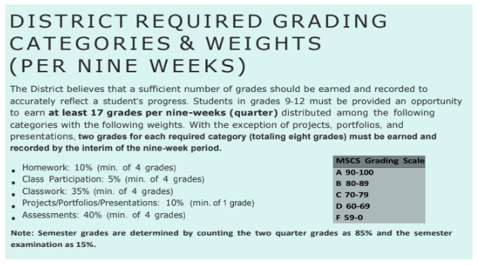

Schoolwide Makeup Work Policy:

It is the primary responsibility of students/parents to obtain the makeup work provided and to complete it in the allotted time to receive full credit earned without point reduction.

If a student has an excused absence, he/she has a total of 3 days for each excused day to submit makeup work (beginning the day after the student returns to school).

If a student had an unexcused absence (including short-term suspensions), he/she has a total of 1 day for each day unexcused to submit makeup work (beginning the day after the student returns to school). The highest grade a student may receive when the absence is unexcused is a 60/D.

A student cutting class will not be allowed to complete makeup work. A student cutting class will have the opportunity to take advantage of grade repair at the end of the nine-week period.

A designated space in the room will be available for students to obtain makeup assignments. Teachers must assign a due date for each assignment.

Once makeup assignments are obtained, students must sign off that the work has been received. Late makeup work will not be accepted.

Tutoring Day(s) and Time(s):
Tutoring will be Tuesdays from 2:30 - 3:30.

.

Statement of Recognition and Agreement

As the parent/guardian of______________________________________________, I have read and understand the classroom rules, polices, and procedures with my child. Should I have any questions or concerns, I may contact the teacher via phone or email, and/or schedule a conference with the teacher.

Student Signature Date

Parent/Guardian Signature Date

